# [East West University](http://www.ewubd.edu/)=

**Project Report**

Group no:

|  |  |
| --- | --- |
| Course Title | Database System |
| Course ID | CSE 301 |
| Section | 01 |
| Semester | Fall 2020 |
| Project Title | Restaurant Management System |

**Submitted To:**

Md Mostofa Kamal Rasel, PhD

Assistant Professor, Department of Computer Science & Engineering

**Submitted By:**

|  |  |  |
| --- | --- | --- |
| Mohammad Nurul Abrar | 2018-1-60-139 | report |
| Sarder Iftekhar Ahmed | 2018-1-60-181 | Er diagram,design description |
| Mohammed Tasiful Alam | 2018-1-60-171 | Sql, ppt |

**Date of Submission:** 04-01-2021.

|  |  |
| --- | --- |
| No | Content |
| 1 | Introduction |
| 2 | Data types |
| 3 | Data Requirements   1. 1.Entities 2. 2.Attributes |
| 4 | Entity Relationship Diagram |
| 5 | Schema Diagram |
| 6 | Relation table |
| 7 | Conclusion |

1. **Introduction:**

Restaurant management system is an application system which are generally small or medium in size. It is basically used by restaurants to manage the restaurants record using the employee details, customer details address, order details, item list, discount, delivery man details, customer rank etc.

It uses different entities to provide best service to customer.

**2. Data Types:**

**1. Integer**: one optional sign character (+ or -) followed by a least one digit (0-9). Leading and trailing blanks are ignored. No other character is allowed.

**2. Varchar**: It used to store alpha numeric characters. In this data type we can set the maximum number of characters up to 8000 ranges by defaults SQL server will set the size to 50 characters range.

**3. Date**: The DATE data type accepts date values. No parameters are required when declaring a DATE data type. Date values should be specified in the form:

YYYY-MM-DD. However, point base will also accept single digits entries foe month and day values.

**4. Time**: The TIME data type accepts time values. No parameters are required when declaring a TIME data type. Date values should be specified in the form: HH:MM: SS. An optional fractional value can be used to represent nanoseconds.

**3.Data requirements:**

* Entities:
  + - * Customer
      * Order
      * Address
      * Employee
      * Customer phone
      * Item
      * Discount
      * Delivery boy
      * Customer rank
* Attributes:
  + - * Customer
        + ID
        + User Name
        + Customer phone
        + Email
        + Status
        + Phone
        + address
* Order

* Order ID
* Order time
* Customer id
* Total purchase
* Order date
* Del_status
* Payment
* P_id
* Card
* Bkash
* Item
* Item_id
* Item_name
* Price
* Description
* Delivery boy

* ID
* Area code
* Name
* Customer rank
* R_id
* platinum
* Golden
* Regular
* Discount
* Discount_id
* Cust_status
* Address:
* Address_id
* city
* Post_code
* Street

->Road

->House

**Design Description:**

In our design, we want to give an online service. We have nine entities. Customers can order through online and able to see our dishes and quality. We have another entity delivery boy to manage the delivery to particular address. The delivery boy has an area code to give service in a particular area according to area code. Here, in our system we have an entity named customer rank which actually stores the ranking of our customer that is platinum, golden and regular. In this design, we have a payment entity and discount entity. Two types of payment is available that is card and bkash. Discount is available according to customer rank.

**4.Entity-Relationship- Diagram:**

An Entity Relationship Diagram (ERD) is a visual representation of different entities within a system and how they relate to each other.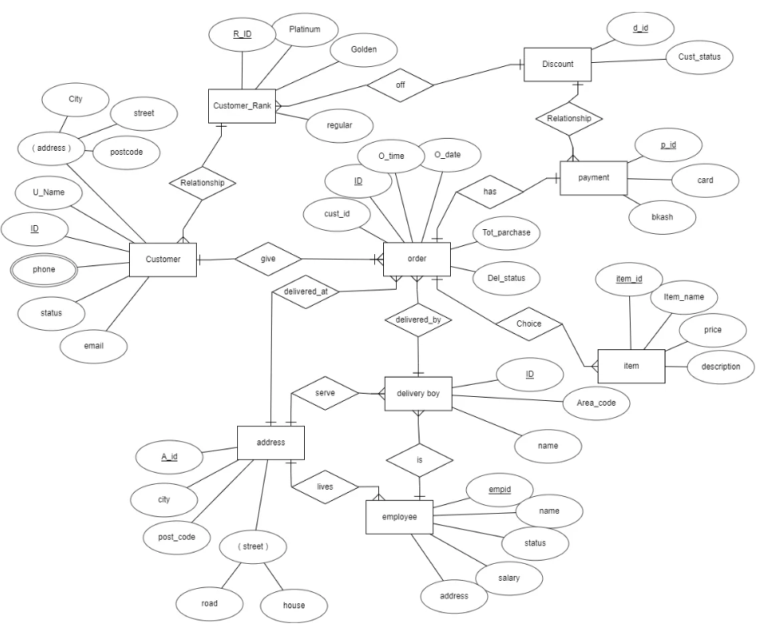

Here in the diagram, we have nine Entities: customer, address, employee, delivery boy, item, payment, discount, order, customer rank.

Customer has six attributes: ID, User Name, phone, Email, Status, Phone. And ID is the primary key, phone number is multivalued attribute and address is composite attribute

Address has four attributes: A_id, City, post_code, street and A_id is primary key and street is composite attribute.

Employee has four attributes: name, status, salary, address. Here empid is primary key.

Delivery boy has three attributes: ID, Area_code , name. Here ID is primary key.

Item has four attributes: item_id, item_name, price, description. And item_id is primary key.

Payment has three attributes:P_id, card, bkash. Here p_id is primary key.

Discount has two attributes:d_id, cust_status. Here d_id is primary key.

Order has six attributes:ID, O_time, O_date, cust_id,del_status, total_purchase. Here ID is primary key.

Customer rank has four attributes:R_id, platinum, golden, regular. Here R_Id is primary key.

**5.Relational Schema:**

A schema is the structure behind data organization. It is a visual representation of how different table relationships enable the schema’s underlying mission business rules for which the database is created. Database schema defines its entities and the relationship among them.

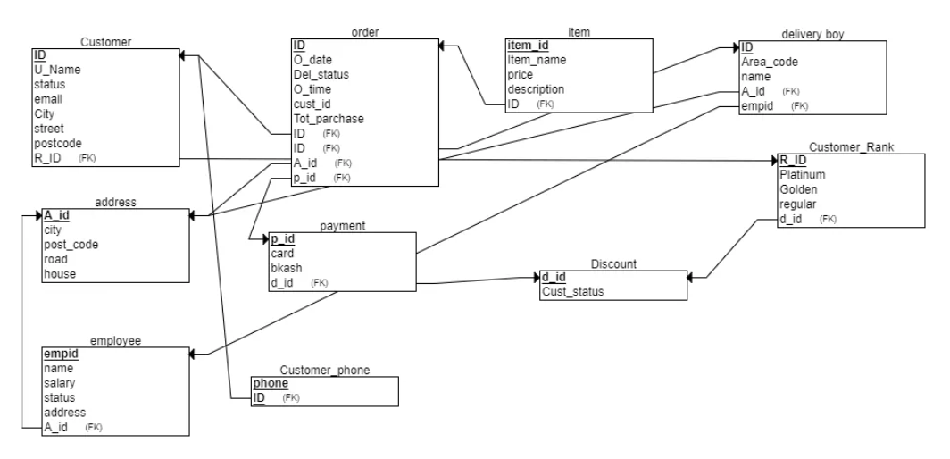

**6. Relationship table:**

|  |  |
| --- | --- |
| Entity | Relationship |
| Customer – Customer Rank | n-1 |
| Discount – Customer Rank | n-1 |
| Discount – payment | 1-n |
| Order - payment | 1-1 |
| Order -Item | 1-n |
| Order – Delivery Boy | n-1 |
| Employee - Delivery Boy | 1-n |
| Employee- Delivery Boy | 1-n |
| Employee- Address | n-1 |
| Address - Delivery Boy | 1-n |
| Order – Address | n-1 |
| Customer – order | 1-n |

**7. Conclusion:** SQL database the board application which is very much utilized in the advanced world in getting sorted out and controlling a database. Despite the fact that SQL doesn't have the GUI interface like Microsoft access is having and they all deal with the database agreeable. Contingent upon the client or clients, on the off chance that an association has different clients, at that point they should go for SQL worker-based application. This undertaking tells the best way to make tables in SQL and how to make basic information control language and information definition language with how to execute them. It likewise shows how connections are set up with the ideas of essential and unfamiliar key inside a table. Finally, the undertaking shows how questions are made in SQL worker, inquiries like the make order, see, update, modify and so on.